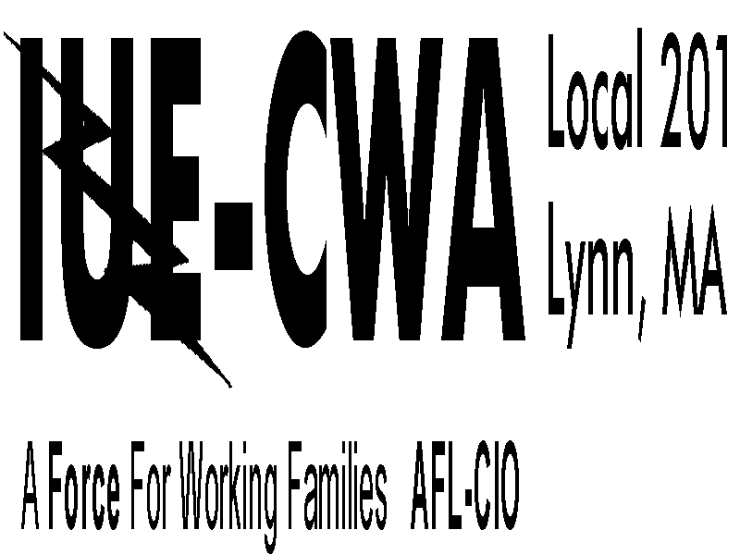
GE Riverworks Manager Conduct Report
Overview
This form has been created by IUE-CWA Local 201 to allow 201 members to report inappropriate conduct by managers. In our experience, incident reports about manager conduct disappear into a black hole once submitted, with no reporting back to the employee who submitted the report. This form will allow 201 members to maintain a record of the incident and allow us to bring the issue forward to Management. This is not a GE form, and it has no automatic contractual effect upon Management at the present time. It does however create proof of notification and the moral obligation by Management to address the issue, and you may rest assured that the Union will pressure Management to address the issue satisfactorily.

(FORM ON THE BACK)
GE Riverworks Manager Conduct Report
Date and Time of Incident:
Manager Name & Department:
Location where Incident Took Place:
Has a formal complaint been filed with HR?: ⃝ YES ⃝ NO
If Yes to the above: Please describe when the complaint was filed, who the complaint was filed with, and any action taken:

State with as much detail as possible what occurred. Please be specific about the manager’s words, physical behavior, and demeanor. You may attach a separate sheet, either typed or hand-written, if there is insufficient room here:

Name: | Work Area:
Usual Shift: | Cell Phone:
Non-GE Email:

TO SUBMIT FORM:
FAX COMPLETED FORM TO (781) 595-8770 ATTN: Britani; OR
EMAIL SCANNED COPY TO office@local201iuecwa.org; OR
DROP OFF IN-PERSON AT THE UNION HALL

